A generic current source inversion algorithm for Mise-à-la-masse prospection

Tentatively in Computer and Geosciences

*Benjamin Mary1,2, Giorgio Cassiani, Luca Peruzzo? Yuxin Wu ? Zlorian Wagner? Guillaume Blanchy?, Andrew Binley?*

1*Dipartimento di Geoscienze, Università degli Studi di Padova, Via G. Gradenigo, 6–35131 Padova, Italy*

2*Earth and Environmental Sciences, Lawrence Berkeley National Laboratory, Berkeley, California 94720, USA.*

Core ideas

* Propose an open source and generic algorithm to invert current source density in Mise-à-la-Masse prospection
* Model appraisal and uncertainties
* Show the application of the algorithm on three different contexts: plant root imaging, landfill leakage and salt intrusion monitoring
* Address pip to download the open source python package “pyMALM”: coming soon

Abstract

*Keywords:* Mise-à-la-masse, inversion, ERT, curent density

1. Introduction

Landfill MALM : (Binley et al., 1997), (Colucci et al., n.d.), (Binley et al., 1999),

Tracer injection:

Roots imaging MALM : (Mary et al., 2020, 2019, 2018)

Inversion MALM : (Shao et al., 2018)

Inversion code (Blanchy et al., 2020)

* 1. Background
  2. Potential of MALM
  3. Existing approaches for MALM inversion

1. Structure of the code
2. Applications
   1. Case of root system imaging
   2. Case of landfill leakage
   3. Case of salt intrusion monitoring

Acknowledgements

This project has received funding from the European Union’s Horizon 2020 research and innovation programme under the Marie Sklodowska-Curie grant agreement No 842922

Figures

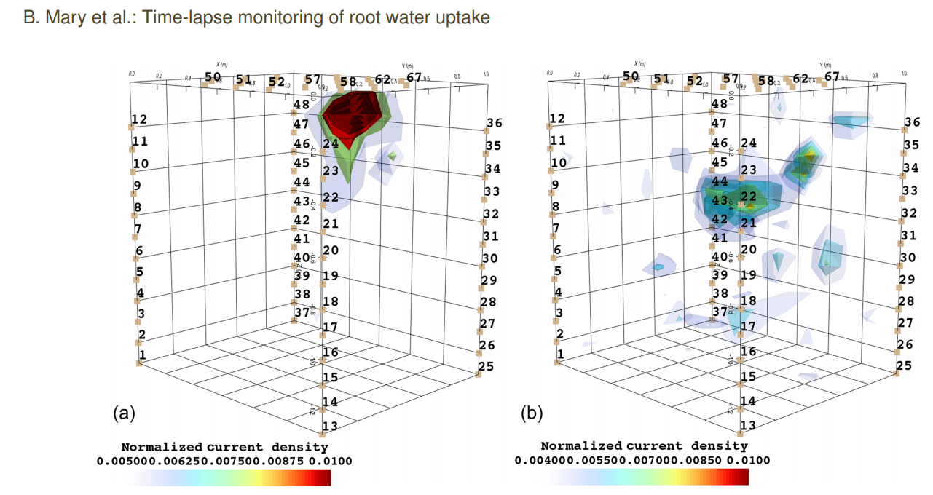

Figure 1: application on root system (ref Mary et al. 2020)

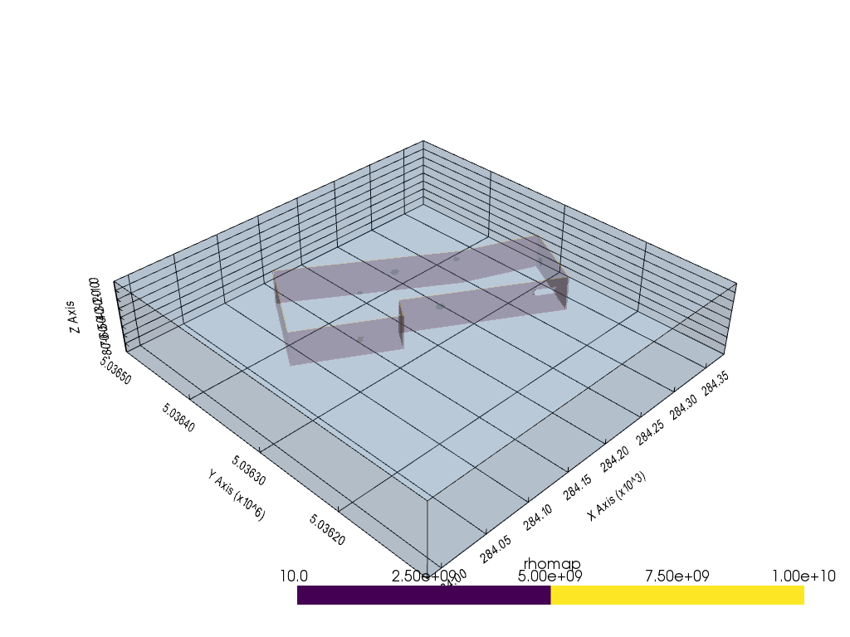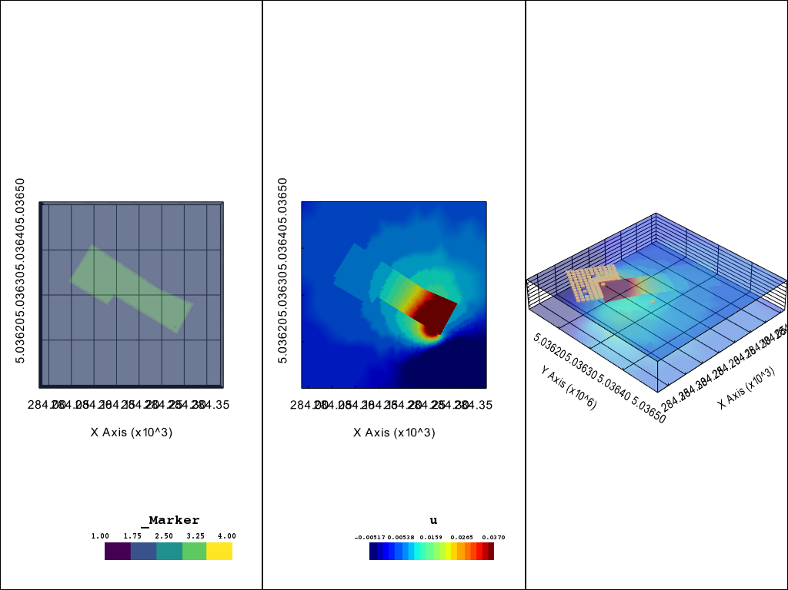

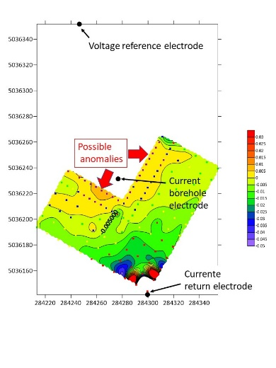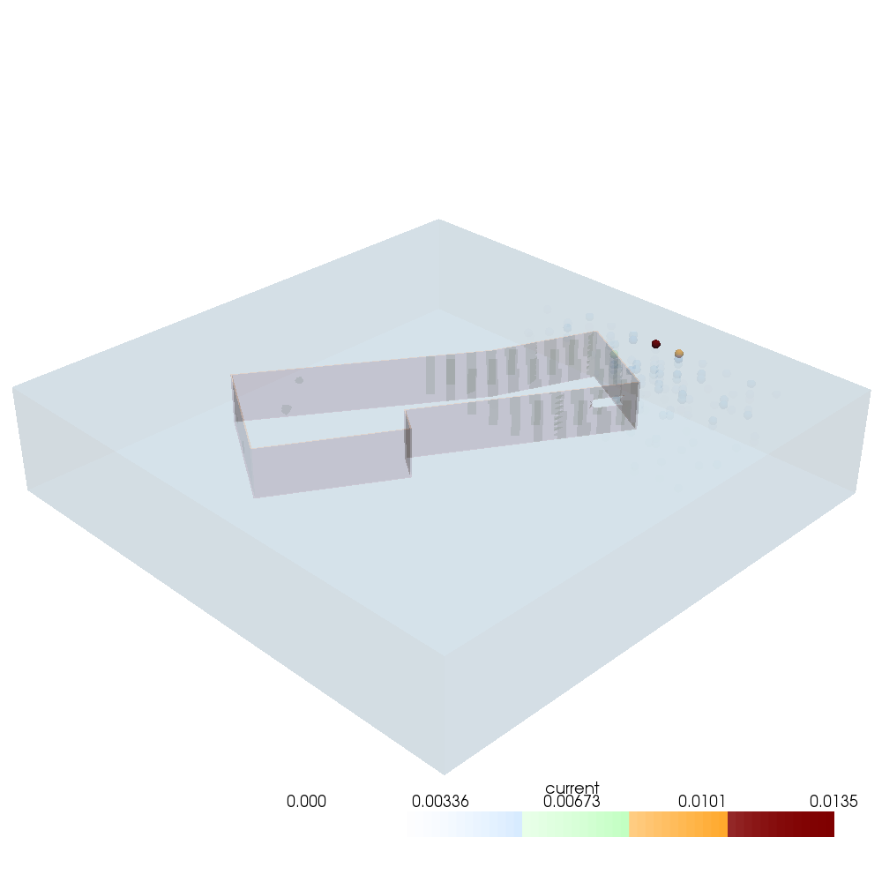

Figure 2: Application of the algorithm on a 3d landfill leakage (Landfill Porto Marghera). (a) initial map of resistivity showing the landfill delineation and the presence of a hole in the liner. (b) result of potential field u for the MALM simulation (c) voltage distribution from field acquisition (d) source current density after inversion of synthetic data. The ICSD shows here all its usefulness when the remote electrodes are not enough distant and pollute the signal and interpretation of equipotential.

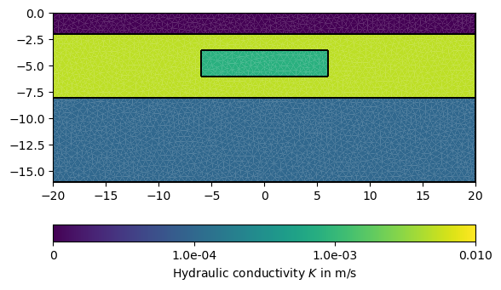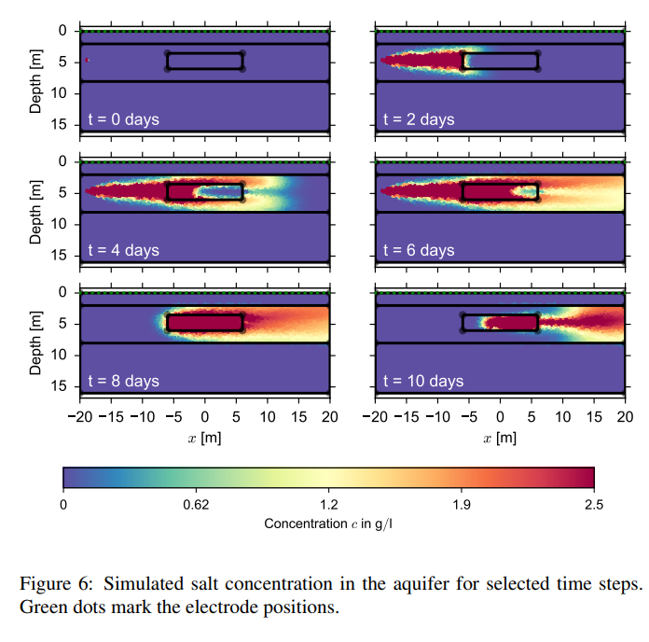

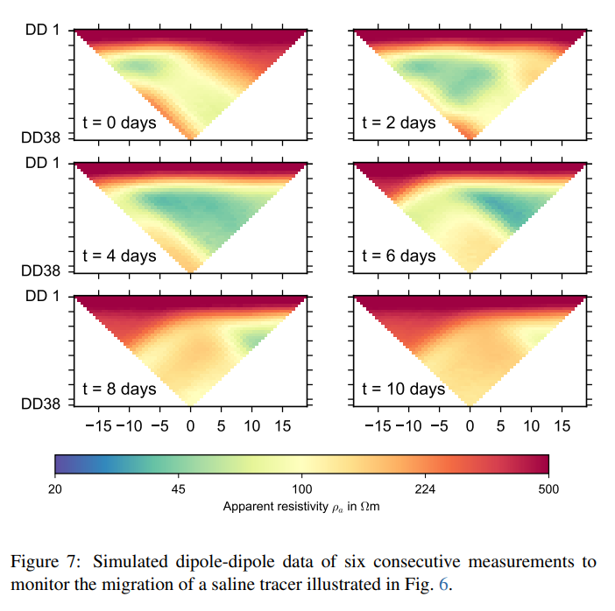

Figure 3: Time-lapse ERT simulation measurements during a saline tracer injection. (a) initial model of hydraulic conductivity (b) simulated salt concentration for selected time steps (c) Simulated dd data. The figures were generated with pygimli and are also described in the pygimli article

|  |  |  |  |
| --- | --- | --- | --- |
|  | Initial resistivity model | Voltage distribution | Fraction of current density (scale from 0 to 25%) |
| T1 |  |  |  |
| T3 |  |  |  |
| T6 |  |  |  |

Figure 4: Result of the inversion of current density (column 3) for different initial resistivity models (column 1) corresponding to different time steps after salt tracer injection.

References

Binley, A., Daily, W., Ramirez, A., 1999. Detecting Leaks from Waste Storage Ponds using Electrical Tomographic Methods 8.

Binley, A., Daily, W., Ramirez, A., 1997. Detecting Leaks from Environmental Barriers Using Electrical Current Imaging. JEEG 2, 11–19. https://doi.org/10.4133/JEEG2.1.11

Blanchy, G., Saneiyan, S., Boyd, J., McLachlan, P., Binley, A., 2020. ResIPy, an intuitive open source software for complex geoelectrical inversion/modeling. Computers & Geosciences 137, 104423. https://doi.org/10.1016/j.cageo.2020.104423

Colucci, P., Darilek, G.T., Laine, D.L., Binley, A., n.d. LOCATING LANDFILL LEAKS COVERED WITH WASTE 5.

Mary, B., Peruzzo, L., Boaga, J., Cenni, N., Schmutz, M., Wu, Y., Hubbard, S.S., Cassiani, G., 2020. Time-lapse monitoring of root water uptake using electrical resistivity tomography and mise-&amp;#224;-la-masse: a vineyard infiltration experiment. SOIL 6, 95–114. https://doi.org/10.5194/soil-6-95-2020

Mary, B., Peruzzo, L., Boaga, J., Schmutz, M., Wu, Y., Hubbard, S.S., Cassiani, G., 2018. Small-scale characterization of vine plant root water uptake via 3-D electrical resistivity tomography and mise-&amp;#224;-la-masse method. Hydrol. Earth Syst. Sci. 22, 5427–5444. https://doi.org/10.5194/hess-22-5427-2018

Mary, B., Vanella, D., Consoli, S., Cassiani, G., 2019. Assessing the extent of citrus trees root apparatus under deficit irrigation via multi-method geo-electrical imaging. Sci Rep 9, 9913. https://doi.org/10.1038/s41598-019-46107-w

Shao, Z., Revil, A., Mao, D., Wang, D., 2018. Finding buried metallic pipes using a non-destructive approach based on 3D time-domain induced polarization data. Journal of Applied Geophysics 151, 234–245. https://doi.org/10.1016/j.jappgeo.2018.02.024

Recent paper of Blanchy and pygimli team

Paper Revil

Papier Maria Theresa

Papier Abdoulsamad et al 2019 leak in a dam